**LAB 1**

**Q1. WAP to take two variables & apply arithmetic operations on it.**

**Ans.**

a = 3

b = 5

name = "kanav"

roll_no = "24BEE107"

print(a + b) # Addition

print(a - b) # Subtraction

print(a / b) # Division

print(a * b) # Multiplication

print(a % b) # Modulus

print("Name:", name)

print("Roll No:", roll_no)

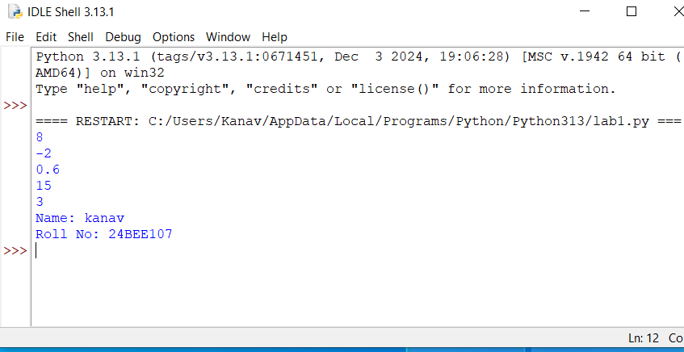

**Q2. WAP to take marks of student in 5 subjects and compute average.**

**Ans.**

a = 25

b = 36

c = 69

d = 65

e = 98

name = " kanav"

roll_no = "24BEE107"

average = (a + b + c + d + e) / 5

print("Average:", average)

print("Name:", name)

print("Roll No:", roll_no)

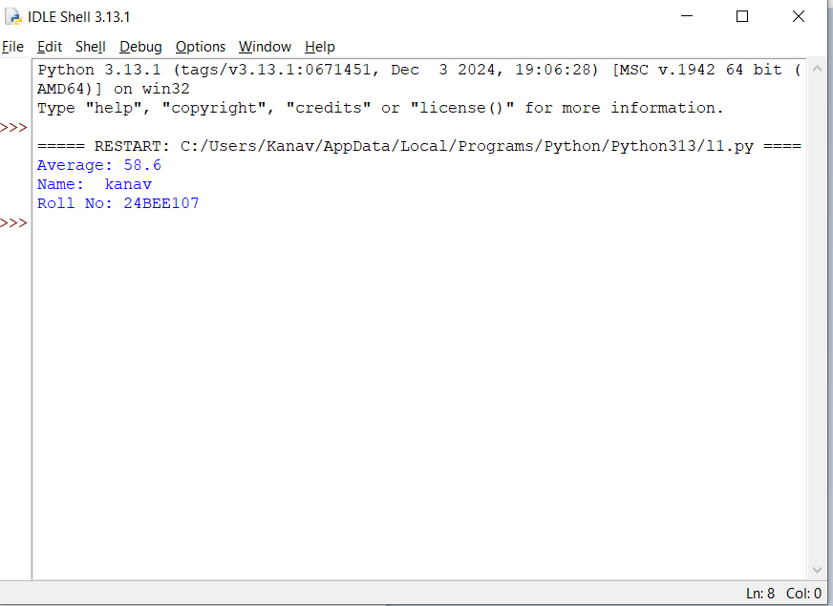

**Q3. WAP to convert a temperature from oC to oF.**

**Ans.  
t = 30  
f = (t * 9 / 5) + 32  
name = "kanav"  
roll_no = "24BEE107"  
print("Temperature in Fahrenheit:", f)  
print("Name:", name)  
print("Roll No:", roll_no)**

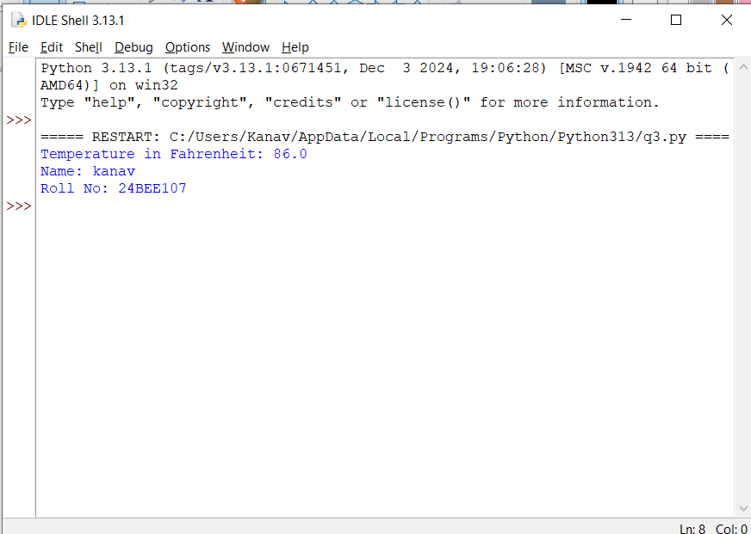

**Q4. WAP to compute area and perimeter of a circle.**

**Ans.  
r = 8   
a = (22 / 7) * r * r   
p = 2 * (22 / 7) * r  
name = "kanav"  
roll_no = "24BEE107"  
print("Perimeter (Circumference):", p)  
print("Area:", a)  
print("Name:", name)  
print("Roll No:", roll_no)**

**i**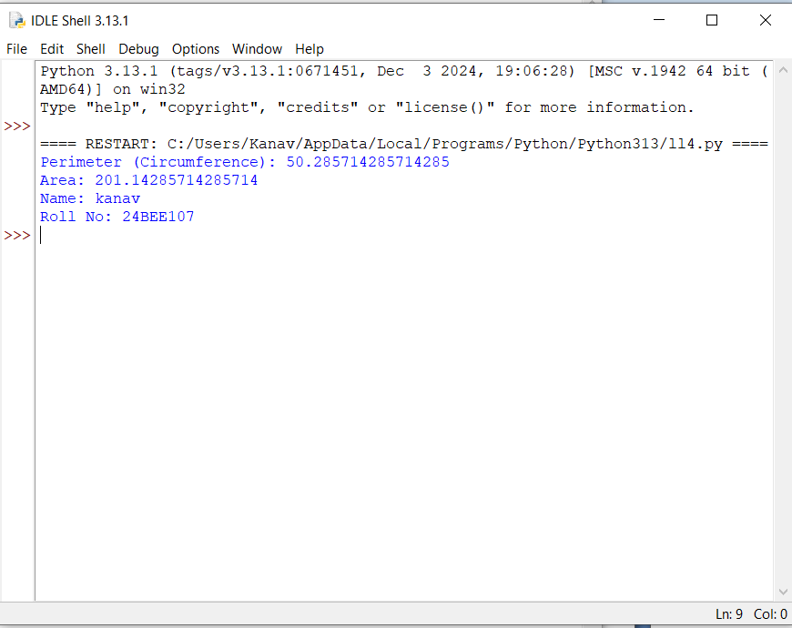

**Q5. WAP to convert from one currency to another currency.**

**Ans.  
dollar = 20   
inr = dollar * 85.84  
name = " kanav"  
roll_no = "24BEE107"  
print("Amount in Indian Rupees:", inr)  
print("Name:", name)  
print("Roll No:", roll_no)**

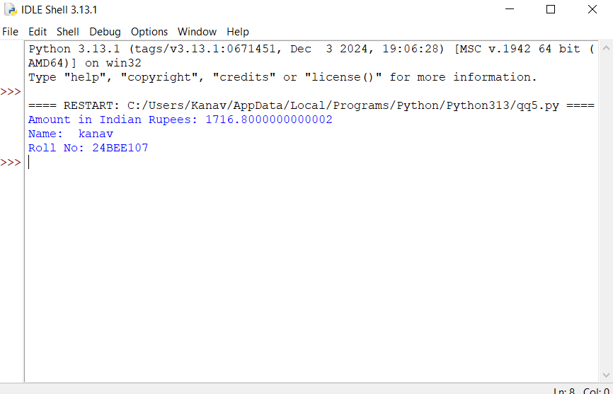

**Q6. WAP to swap to values.**

**Ans.  
a = 12  
b = 13   
temp = a  
a = b  
b = temp  
name = " kanav "  
roll_no = "24BEE107"   
print("Value of a after swapping:", a)  
print("Value of b after swapping:", b)   
print("Name:", name)  
print("Roll No:", roll_no)**

